class Student
{
public int Id { get; set; }
public string Name { get; set; }
public int Age { get; set; }
public int Marks { get; set; }
public string City { get; set; }
}

List<Student> students = new List<Student>
{
new Student { Id = 1, Name = "Alok", Age = 20, Marks = 85, City = "Delhi" },
new Student { Id = 2, Name = "Riya", Age = 22, Marks = 72, City = "Mumbai" },
new Student { Id = 3, Name = "Rajat", Age = 19, Marks = 78, City = "Delhi" },
new Student { Id = 4, Name = "Nitya", Age = 21, Marks = 88, City = "Pune" },
new Student { Id = 5, Name = "Raman", Age = 23, Marks = 65, City = "Bangalore" },
new Student { Id = 6, Name = "Smita", Age = 22, Marks = 92, City = "Mumbai" },
new Student { Id = 7, Name = "Saket", Age = 19, Marks = 58, City = "Delhi" },
new Student { Id = 8, Name = "Prachi", Age = 21, Marks = 88, City = "Pune" },
new Student { Id = 9, Name = "Naresh", Age = 23, Marks = 95, City = "Bangalore" },
new Student { Id = 10, Name = "Aarti", Age = 22, Marks = 84, City = "Mumbai" },
new Student { Id = 11, Name = "Vartika", Age = 19, Marks = 78, City = "Delhi" },
new Student { Id = 12, Name = "Manan", Age = 21, Marks = 88, City = "Pune" },
new Student { Id = 13, Name = "Mahesh", Age = 25, Marks = 77, City = "Chennai" },
new Student { Id = 14, Name = "Ranjeet", Age = 22, Marks = 96, City = "Mumbai" },
new Student { Id = 15, Name = "Kajal", Age = 19, Marks = 78, City = "Chennai" }

};
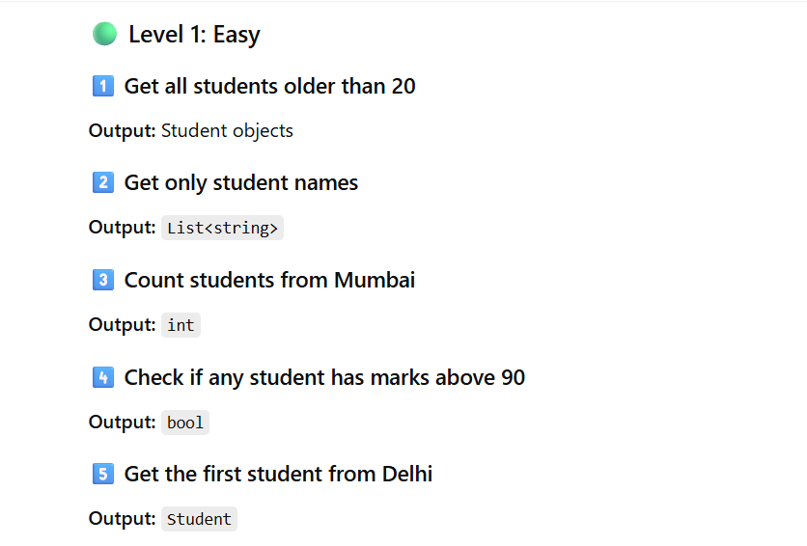

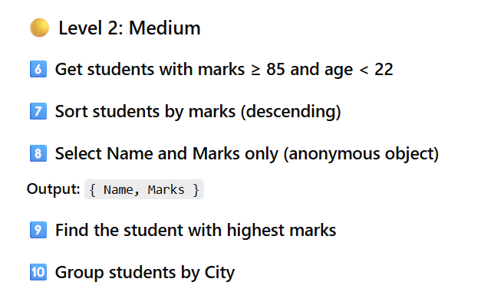

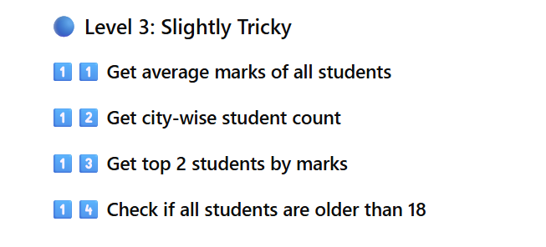

LEVEL 1 – EASY (Solutions)

1️⃣ Students older than 20
var q1 = students.Where(s => s.Age > 20).ToList();

2️⃣ Get only student names
var q2 = students.Select(s => s.Name).ToList();

3️⃣ Count students from Mumbai
var q3 = students.Count(s => s.City == "Mumbai");

4️⃣ Any student with marks above 90?
var q4 = students.Any(s => s.Marks > 90);

5️⃣ First student from Delhi
var q5 = students.FirstOrDefault(s => s.City == "Delhi");

LEVEL 2 – MEDIUM (Solutions)

6️⃣ Marks ≥ 85 and Age < 22
var q6 = students
.Where(s => s.Marks >= 85 && s.Age < 22)
.ToList();

7⃣ Sort by marks (Descending)
var q7 = students
.OrderByDescending(s => s.Marks)
.ToList();

8️⃣ Select Name & Marks only
var q8 = students
.Select(s => new { s.Name, s.Marks })
.ToList();

9️⃣ Student with highest marks
var q9 = students
.OrderByDescending(s => s.Marks)
.FirstOrDefault();
✅ Alternative (Recommended):
var q9_alt = students.MaxBy(s => s.Marks);

🔟 Group students by City
var q10 = students
.GroupBy(s => s.City)
.ToList();
Usage:
foreach (var group in q10)
{
Console.WriteLine(group.Key);
foreach (var student in group)
Console.WriteLine(student.Name);
}

🔵 LEVEL 3 – TRICKY (Solutions)

1️⃣1️ Average marks
var q11 = students.Average(s => s.Marks);

1️⃣2️ City-wise student count
var q12 = students
.GroupBy(s => s.City)
.Select(g => new { City = g.Key, Count = g.Count() })
.ToList();

1️⃣3 Top 2 students by marks
var q13 = students
.OrderByDescending(s => s.Marks)
.Take(2)
.ToList();

1️⃣4️ Are all students older than 18?
var q14 = students.All(s => s.Age > 18);

⭐ BONUS: Query Syntax Example

Students older than 20
var bonus =
from s in students
where s.Age > 20
select s;

